How to Expand your Vocabulary
A rich vocabulary is essential for speaking English fluently. One of the great ways to improve your vocabulary and learn new words is to complete crossword puzzles. Below is a fun summer-themed crossword puzzle created for you, the reader of our CanPacific blog. Check it next week to see the solution. Have fun!

ACROSS | DOWN
3 The second month of summer  6 Toronto's basketball team  7 An afternoon snooze in Spain  9 A frozen dessert made from milk  11 What you can do at the beach  12 Protects skin from the sun  14 One of the summer Olympic sports  15 A sport with rackets | 1 Toronto's baseball team  2 The sport of riding waves  4 The season before summer  5 A team sport with a ball and sticks  8 Saturday and Sunday

Puzzle created using www.puzzle-maker.com

The Summer Fun Crossword: Solution
Here is the solution of last week’s puzzle:
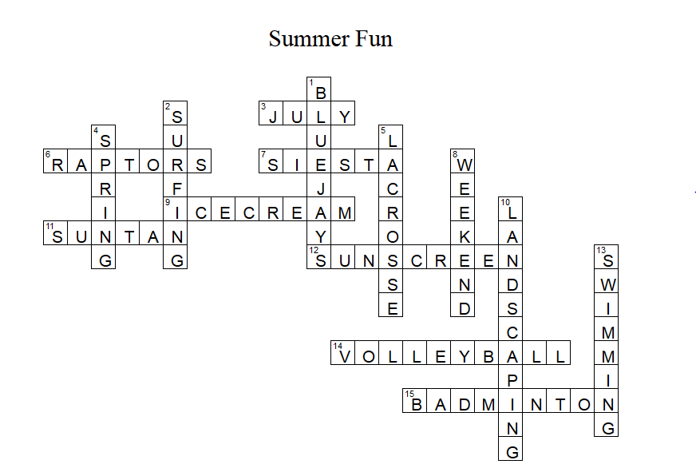
Check the blog for more tips on how to improve your English.

